The sensor tag contains the Accelerometer, humidity, temperature, pressure and Gyroscope sensors. This Lab assignment deals with collecting the values from the sensor Tag and Android device and generates the text file containing these data values.

This assignment also deals with interacting with the Hbase using the JDBC and uploads the collected sensor data to the table created in the Hbase database.

**Table created in HBase :** [SensorTagTableGroup4](http://134.193.136.127:60010/table.jsp?name=SensorTagTableGroup4)

The following screenshots display the data collected using different sensors:

**Data collected from Accelerometer:**

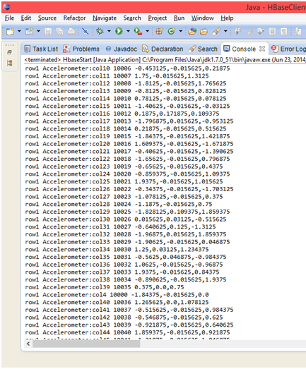

**Date collected from the system:**

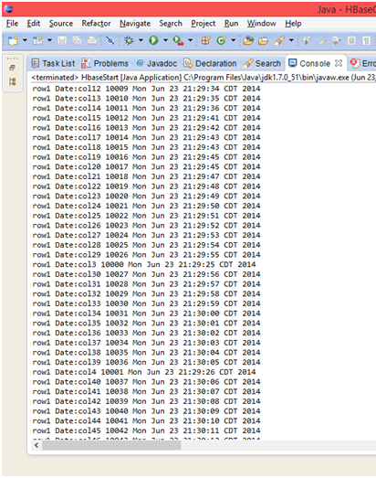

**Geo Location Data collected from Device:**

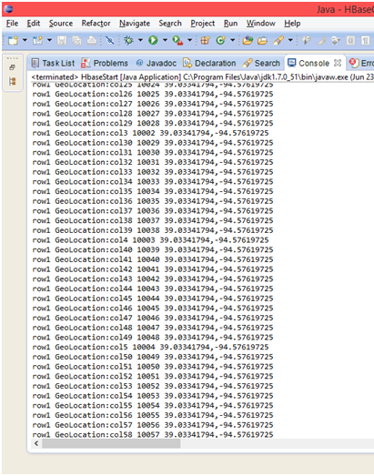

**Data collected using Gyroscope sensor:**



